1. Shadow effects for objects in canvas are not present currently in project
2. Shadow effect is not present for shapes.

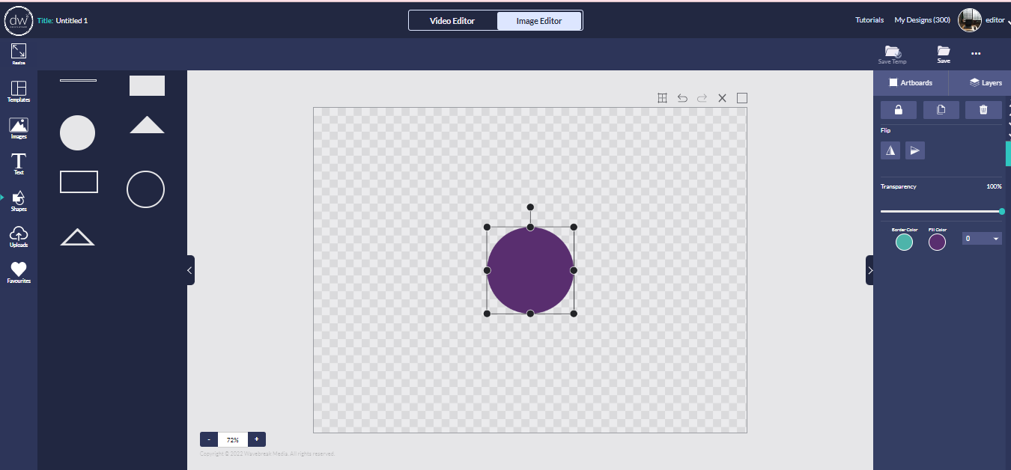

1. shadow effect is not present for text.

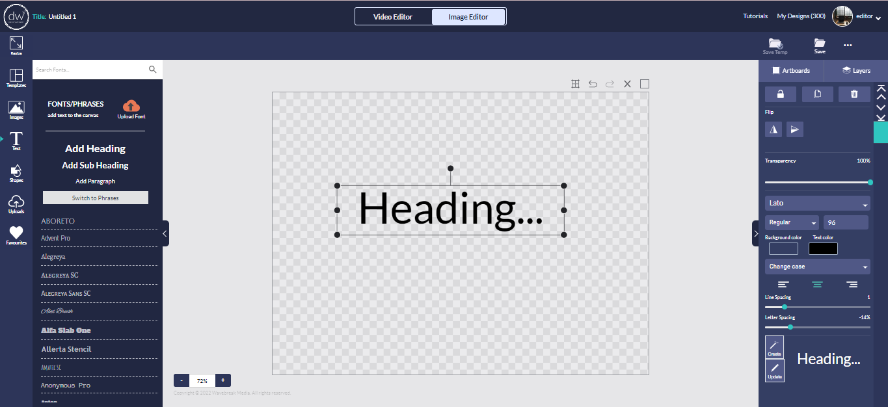

1. shadow effect is not present for image.

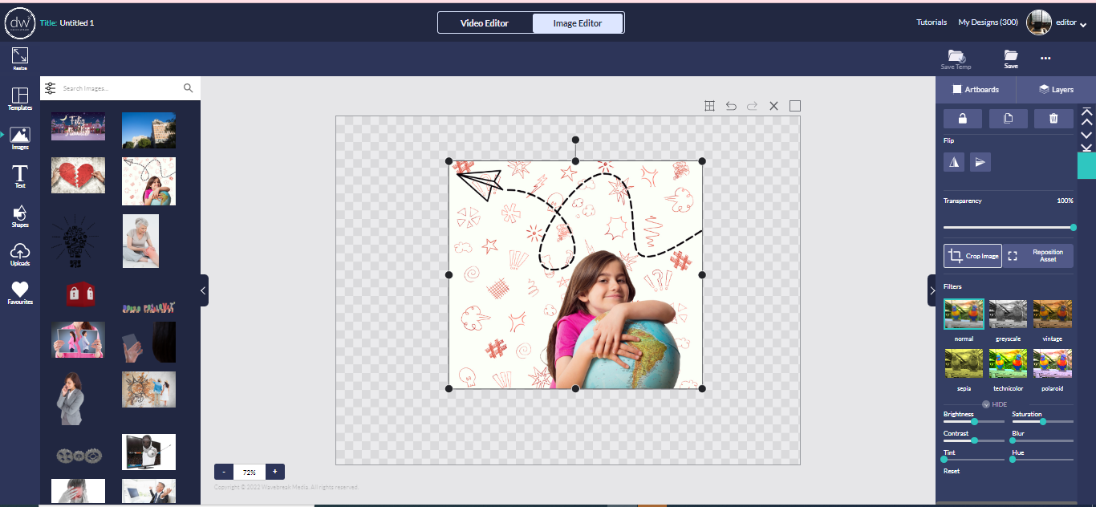

1. we can provide shadow effects for text, shapes, and image . Like offset, direction, blur, transparency , shadow color.
2. For example

